https://www.westmarine.com/WestAdvisor/DIY-Preparing-For-An-Offshore-Race

Do-it-Yourself: Preparing for an Offshore Race
By Chuck Hawley, Last Updated 4/16/2019
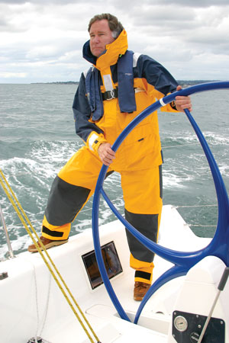
Chuck Hawley

Introduction
Preparing for an offshore race can be a daunting challenge, with hundreds of tasks involving boat preparation, crew training, sail selection, last minute haul outs, and so forth. For most of the world's sailboat races, the document that determines what gear you must carry is the World Sailing Offshore Special Regulations Governing Offshore Racing for Monohulls & Multihulls, frequently referred to as the Special Regs. US Sailing, the national governing organization for sailing in the U.S., adds modifications to the World Sailing (formerly ISAF) version of the Special Regulations.
While you can buy the booklet containing the Special Regs from US Sailing, it is now possible to download either the complete book or an extract directly from the US Sailing website. An extract is a portion of the Special Regs that contains only the information that pertains to your race. In the case of the Pacific Cup or Transpac, it is a Category 1 race for monohulls, one of the ten extracts listed on the site. The extract is a PDF document which can be saved or printed.

Modifications to the Special Regs
Oh, if only that was all there was to it! The challenge is that well-meaning race organizers, safety of life at sea (SOLAS) committees, and board members are reluctant to leave the World Sailing or US Sailing version of the Special Regs intact. Inevitably, the Notice of Race (NOR) will contain a list of modifications to the Special Regs that adapt them for the special conditions present in the race you are entering. Common modifications include:
- Minimum water requirements
- Height of lifelines
- Number and type of flares (pyrotechnics)
- Carriage of a SSB, Inmarsat C, or Iridium phone
- Inboard engine requirement
- Amount of fuel to be carried
Many of the changes to the Special Regs will be justifiable based on the duration, course or conditions that are likely to be experienced during the race and some are based on personal biases. Regardless of the origin, you need to abide by the modified Special Regs so make sure that you are aware of the changes present in the Notice of Race and the subsequent Amendments.
Generally, the person responsible for preparing a race boat and passing the Category 1 inspection will be the boat owner, owner’s representative or a boat captain. The process of preparing a boat for the inspection can be very time consuming, especially if the boat is either new or has never gone on an extended passage before. Even owners of well-found cruising boats will find that there are construction details and required gear that is not on board, and will either have to be bought, borrowed, or rented for the race (and quite possibly the delivery home).
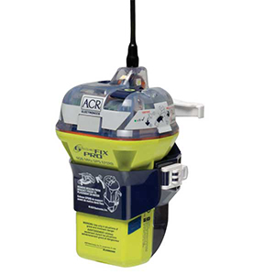
GlobalFix™ PRO EPIRB.

Should I Rent (or Borrow) the Gear?
The cost of buying all of the required gear for a Category 1 race can easily exceed $20,000, and many owners will only participate in a single race every year or possibly two years. It’s challenging to justify the purchase of some of the required items if you’re going to be storing them in your garage for the following 23 months. So what items might make sense to either borrow or rent and what are the challenges in doing this?
Life Rafts: Safety experts are divided on this one. The argument for renting a life raft is that they are expensive to purchase ($3,000 to $6,000), require maintenance every few years, and have a very small chance of ever being put to use. The argument for buying a raft is that there have been documented instances of rental rafts which have been sabotaged at some point in their history rendering them completely ineffective had they been needed. If you’re tempted to rent a raft, get in contact with your local life raft repacker early in the process (like as soon as you decide to race) and see if he or she rents rafts. If so, make sure that he or she understands the requirements of your race so that you rent a raft that is “legal”.
If you decide to rent a raft from a friend or a guy on craigslist.org, you must have the raft repacked early in the process by a factory-authorized repacker who will then certify the raft for another 1, 2, or 3 years. If the raft fails inspection for some reason you need to have sufficient time to find an alternate solution.
EPIRBs: Emergency position indicating radio beacons have to be registered with information about your vessel and how to get in touch with your emergency contacts. Any organization that rents EPIRBs (like BoatU.S.) knows this, and will arrange to let NOAA and the Coast Guard know who’s actually in trouble. Therefore, if you’re going to borrow someone else’s EPIRB, it must be re-registered through NOAA while you’re using it. Note that you’ll need the beacon ID and the password for the beacon to change the information online.
INMARSAT and Iridium Phones: While these are incredibly handy devices, it’s hard to justify the purchase for a single race. Make sure you calculate the entire cost of the rental, shipment to and from the renter, and the cost of a SIM card for the duration of the race and the return.

The Six Sections of the Special Regulations
You should read the entire extract that applies to your race (again, generally Category 1 Monohulls), whether or not it actually addresses items that you’ll be responsible for carrying. There’s some really good content in the Fundamentals and Definitions (Section 1) as well as the definitions of what each Category means (Section 2). The gear sections are 3-5, with a final section on training (Section 6). Also, read the appendices that apply to your race, especially Appendix F, which describes one method of inspecting a boat for offshore racing.

Section 1—Fundamentals and Definitions

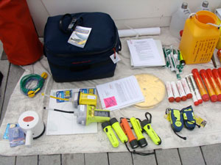
This professionally prepared boat will pass inspection easily.
This section describes, much like the first few rules in the Racing Rules of Sailing, what the purpose of the Special Regs is, and who is responsible for carrying them out (generally you). It also contains a lengthy list of abbreviations in Table 1 which are helpful in unlocking the secrets in the following sections.
Pay special attention to 1.02, which deals with who’s responsible when a yacht participates in a race. While it doesn’t specify the owner or captain, it does use the term “person in charge” which is generally the owner or charterer. The “person in charge” is ultimately responsible for the condition of the yacht, the preparedness of the crew, and the fact that all of the gear called for in the Special Regs is on the boat and ready to be put to use. There have been some instances (they are relatively rare, thankfully) where yachts have been found to be deficient in some regard. The deficiency could be in the accuracy of a rating certificate, or whether or not the crew moved ballast during a race, or whether or not a particular piece of safety gear was carried aboard. It’s embarrassing to note that on some occasions, the “person in charge” abdicates his or her responsibility by blaming someone else for that deficiency. Common scapegoats include the crew, the boatyard manager, the pre-race inspector, the measurer, someone at US Sailing, the race committee, etc.
Participating in a sailboat race is one of the relatively few remaining situations in life where you take full responsibility for something; in this case the preparation of a sailboat to go to sea, to race according to the rules and to operate the boat in a seamanlike manner. It’s not to be taken lightly which is one of the reasons that racing a sailboat offshore has such a dedicated group of participants.

Section 2—Application and General Requirements

Section 2 defines the various race Categories from Category 0 (circumnavigations in completely inhospitable areas) to Category 6 (inland, daytime races). Since Category 1 races are “adjacent” to the strictest, most regulated races, it should serve as a gentle warning to the prospective participant that he or she is about to embark on a challenging endeavor. Category 1 races, using the US Sailing prescription definition are “of long distance, well offshore, in large unprotected bays, and in waters where large waves, strong currents, or conditions leading to the rapid onset of hypothermia are possible, where yachts must be completely self-sufficient for extended periods of time, capable of withstanding heavy storms and prepared to meet serious emergencies without the expectation of outside assistance.”
Of course, this is intended to put the fear of God in you so that you don’t enter a Category 1 race with the presumption that you can buffalo your way through the inspection, preparation, or selection of crew that is required.
One frequently quoted fact is that when you are half way from the West Coast of California to Hawaii, you are as far from land as any place on the Earth’s surface. 1,100 nautical miles to Hawaii, and 1,100 miles to either Southern or Northern California (oh, and 12,000 feet to the bottom of the Pacific.) You are in the oceanic equivalent of the Sahara Desert or the Northwest Territories. It’s entirely up to you as to whether you’ll be able to complete the second 1,100 miles, based on your boat selection, boat preparation, crew selection and ability to jury rig that which breaks along the way. There are no awards for fixing an inadequately prepared boat and limping into Honolulu or Kaneohe Bay or Hilo. It’s expected that you’ll have a successful voyage without outside assistance and without theatrics.
Pay special attention to 2.03. It says that a yacht must be prepared to be inspected at any time. In general, yachts are inspected prior to the race as part of the preparation process and they may be inspected at the finish line to ensure compliance. Some race organizers inspect random boats as they finish (like every fifth boat), others inspect boats that are likely to do well and some inspect 100% of the finishers. What gets inspected also varies. In some instances, the race committee will inspect a predetermined list of 5-10 items which (possibly) have a likelihood of non-compliance. In other cases, they will look for items noted on the pre-departure inspection as being deficient. The point is that you should never embark on a race hoping that no one will notice that you're missing required items and, more importantly, that you should never blame the race committee, your shoreside inspector or the finish line inspector for discovering that you drank your emergency water or forgot your trysail. Buck up! Take responsibility for the seaworthiness of your vessel or don't compete.
Those who value fairness and seamanship also value Section 2.04. The Special Regs are not there to cause you to buy a bunch of equipment you’ll never use, nor are they intended to make your boat uncompetitive. They exist to allow you to leverage the accumulated wisdom of tens of thousands of sailors in hundreds of races. Section 2.04 says that if you’re going to put all this gear on your boat, make sure it’s going to work as intended. The gear has to be accessible, sized correctly and in working order. That means that if it says to have “an anchor with suitable combination of chain and rope”, that you shouldn’t show up with an undersized aluminum anchor with a cut-down anchor stock (which happens to fit between your stringers), 10' of 1/4" of chain and 150' of rode. Plus, that anchor and rode has to be stored securely so that if the boat inverts the anchor and rode will not become a source of danger to the crew.

Section 3—Structural Features, Stability, Fixed Equipment

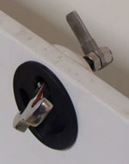
Inside-outside latching mechanism.
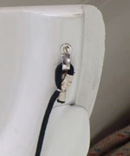
Drop boards with lanyards to prevent their loss in heavy seas.
We think of Section 3 as being the “naval architect’s” section since it involves so many aspects of the boat’s construction or dimensions which were decided when the boat was built. If you own a Crab Crusher 35 and you don’t know if your boat meets the requirements of Section 3, engage a naval architect to help you decide.
Regulation 3.08.4 is a challenge to many owners of production boats who wish to race. It says that you can’t lock someone down below or lock someone from coming below using the companionway latch. The thought is that either party (below decks or on deck) should be able to gain passage to the other location. We’ve seen solutions with a single rotating latch that can be operated from either side of the drop boards as well as securing pins which could be pushed out from above and below decks. Your boat may require a slightly customized solution, so look at some other veteran boats to see how they have solved the problem.

Bilge Pump and Cockpit Drains
Regulation 3.23.3 says that a bilge pump cannot share a cockpit drain as a means to rid the boat of water. Some ULDB designs have large, properly located cockpit drains which can rapidly empty the cockpit if a wave boards from astern, but also have a bilge pump connection to the drain. In that case, reroute the bilge pump discharge to a separate though hull.
Regulation 3.09.5 describes the number and size of cockpit drains so that a flooded cockpit will drain in a reasonable amount of time. It’s difficult to understand and some older production boats may have inadequate scuppers/drains. Boats under 28' must have 2 x 25mm drains, while larger boats must have 4 x 20mm drains or the equivalent. Heavens, who can figure this out? On the other hand, draining any cockpit quickly is a virtue that will aid in the boat’s ability to survive a storm, so, by all means, upgrade your drains if you are close to the margin.
Regulation 3.10 says that, with a few exceptions, you need to have seacocks or valves on through-hull openings below the waterline. Is that the heeled waterline or the static waterline? The Regs are conspicuously silent, but the point is that you need to be able to close off holes your hull with either valves or tapered plugs.
In the vast majority of situations, gravity and your standing rigging provide a force which is more than adequate to keep your mast on its step. But in extreme conditions or when there is an unexpected reduction in shroud tension masts can shift or jump and end up as a potent source of hull leaks. This is why regulation 3.12, requires that masts be attached to their mast step. We’ve seen stainless steel bolts, pieces of 1 x 19 wire with wire clamps, Spectra lashings, and other solutions to this challenge. You never, ever want to be on a boat with a mast butt that is jumping around, so make sure your solution immobilizes it.

Lifelines and Stanchions
Regulation 3.14 goes on and on about lifelines and stanchions. Small boats (less than 28') need to have either single or double lifelines of 1/8" diameter, depending on their age. Medium length boats (28'-43') need to have double lifelines of 5/32" diameter, while boats larger than 43' need to have double 3/16" lifelines. Due to the corrosion that may occur undetected in vinyl-coated wire, it’s now required to use uncoated 1 x 19 wire or the same diameter of Dyneema single braid. Note that Spectra is the same as Dyneema, and both lines are very strong, low-stretch, and abrasion-resistant. Read all of Regulation 3.14, because it goes into detail about openings in the lifelines, as well as the distance between stanchions (2.2m maximum).
Racing boats take widely varying approaches to prepare and cook meals at sea. Some Transpac and Pacific Cup skippers will have prepared meals from fine mainland restaurants or caterers which are popped into the oven and served with fine wines. Other crews suffer mightily, eating three meals a day of “salty green slurry” in the words of Stan Honey. Cook stoves are now allowed to use small LPG containers which exist inside the hull but contain so little gas that they would not make the atmosphere explosive if they empty into the cabin.

Potable Water Requirements
Regulation 3.21 deals with potable water. This is where different races really vary in their requirements for several reasons:
- The race organizers don’t want you to run out of water.
- The race organizers don’t want you to use potable water for movable ballast.
- The race organizers understand you may have a watermaker.
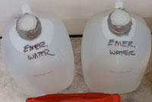
Seal it, label it and don’t use it.
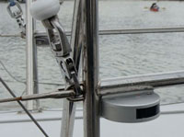
LED side lights above the sheerline.
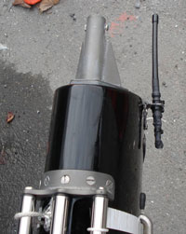
This extremely well-maintained yacht has a “rubber duck” antenna at the masthead compromising the crew’s safety in exchange for a reduction in weight aloft. Pretty embarrassing.
Transpacific races have frequently required 15 gallons per person at the start and two gallons (total) at the finish. Check your NOR to make sure you understand the amount of water you need to start with and the amount of water you can make and move. If you’re dumping water on one gybe and making water into a non-centerline tank on the opposite gybe, you’re likely cheating. Many wonderful, seaworthy boats have bilge pumps which discharge into a scupper and therefore violate 3.23.2. You’ll need to reroute the discharge so that it discharges through the hull, and not directly into the cockpit unless you have an open-transom boat. You may question the wisdom of discharging your bilge water into your cockpit, but that’s up to you.

Bilge Pumps
You need two manual bilge pumps; one operable from above decks and one operable from below decks (3.23.1). Boats with segmented bilges often show up at inspection with a movable intake line that can be moved to wherever the bilge water accumulates. It’s debatable whether a permanently-installed pump can have a movable intake hose, but we leave this to you to debate with your inspector.

Navigation Lights
Ocean-going yachts need navigation lights just as ocean-going ships do. Sails present a challenge since they are variable in size and aspect and can obscure the most professionally installed navigation lights. For maximum visibility, the Special Regulations require that lights be no lower than the sheerline and preferably at the height of the lifelines (3.27.1). Realistically, if your boat is under 20m (65') in length the best way to meet the navigation light requirements is with a masthead tricolor light which is visible over long distances due to its height and is seldom masked by sails.
In addition to a set of navigation lights, the Special Regs require a second set of “reserve navigation lights” (3.27.3) which also meet the COLREGS visibility requirements. Since your boat has an engine and you cannot use a tricolor light for motoring, it’s presumed that you also have deck-level sidelights and a stern light which can be used for your “reserve” lights. What’s not acceptable is to conjure up a loose set of wires and lights and alligator clips with duct tape to present to your inspector as a reserve set. Nor is it acceptable to have a trio of small boat flashlight-style lights that are unacceptable for a panga in Nicaragua, let along a Crab Crusher 35. Have two sets of “real” lights that work independently, so that if a single system on your boat is incapacitated you won’t render both light systems inoperable.

Engine Requirements
Category 1 boats generally have to have inboard engines although the Pacific Cup has allowed outboard-powered boats in the past and the Singlehanded Transpac didn’t require any engine at all. Race organizers are concerned with two situations: first, that an engine is only useful if it’s immediately available to propel the boat, and second that a fuel or exhaust system that is not permanently installed may pose a danger to the crew.
Good seamanship and practicality dictate that you need two batteries especially if you rely on your engine to charge your batteries which you need a battery to start (3.28.4). Again, this varies from race to race. Some races allow a “greener” alternative to using the propulsion engine to charge batteries, but regardless of your charging source, there will be a time in every sailor’s life when he or she tries to use a battery that is dead as a doornail. A second battery that is fully charged and easily accessible is vital.

Radios and Satellite Phones
Finally, you need to be able to communicate with your race committee, the Coast Guard and (possibly) your family. This generally means that you need to have a 25-watt VHF radio with a masthead antenna (please, not some rubber-duck antenna with no gain that’s strapped to your mast), a waterproof handheld VHF radio and either a Single Sideband radio or a satellite phone for long distance communications. If you want to have a long-winded debate, walk into a yacht club bar and express a preference for satellite communications vs. Single Sideband. While it might be an interesting debate (or not!), it only really matters what your race committee requires. Everything else is just a personal opinion and an option that you can add if you like.
Tall masts require lots of coaxial cable to reach the masthead and that coax has signal loss along every foot. Helpful sailors have calculated just how large the coax has to be to reach the antenna with less than a 40 percent loss in signal strength. (Hint: you’re required to have larger coax than you actually want.)

Section 4—Portable Equipment and Supplies

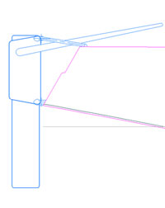
Example of a “cassette” emergency steering rudder. Courtesy of Jim Antrim, Naval Architect.
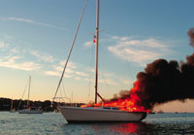
Galley fires can spread quickly. Photo courtesy of BoatUS.
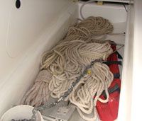
Under the sole, but why is the stock cut off?
Of all of the items required for taking a racing sailboat offshore, the least technologically sophisticated may be found in Section 4.03. Through-hulls and hoses may fail at sea and when they do they let in a prodigious amount of water. A simple tapered wooden plug does wonders for stemming the flow from holes in plumbing and if it’s dry when inserted can swell to form a watertight plug. Tie one tapered plug to each through-hull and suspend it away from bilge water to keep it relatively dry. A small brass screw eye can be used as a lanyard attachment point.

Jackstays
Jackstays, trolley lines, or jacklines: whatever you call them, they are an integral part of staying onboard in rough conditions. They can be made of webbing or wire but many prefer webbing since it is less of a tripping hazard on deck. Jacklines do not have to run to the transom but should run within 2m of the bow and stern. Don’t use standard flat webbing that is used to reinforce the corners of sails. Use heavy nylon or preferably polyester webbing with a strength of at least 6,000lb. You can use a luggage hitch on the forward anchor point (something strong, like a pad eye, toe rail, or mooring cleat) and then lash the aft eye to another strong point using small Spectra line. By taking several passes of Spectra single braid through the sewn eye and the fixed point you can create a turnbuckle of sorts that can exert lots of tension and be as strong as the line you’re attaching.

Fire Extinguishers
Fire extinguishers (always a good idea when at sea) are only mentioned in passing in Section 4.05.2, but they turn out to be larger (2kg or 4.4lb.) than the standard B-I extinguisher in the U.S. plus you’re required to have two. Good idea, but if you’re sailing in a Category 1 race in a small boat (Mini 6.5, Moore 24), it’s unlikely that you’ll be thinking of anything other than the 2.5lb. Coast Guard-approved requirement. It’s a shame; this rule should take into consideration the LOA of the vessel, but apparently doesn’t.

Anchoring
Of all of the requirements in the Special Regs, the one which has the least detail, but upon which volumes have been written, is the lowly anchor and rode. Boats over 28' (why 28'?) are required to have two anchor setups, while smaller boats need one. Since anchors and chain are generally made of steel, and since weight conscious racers abhor steel, there’s a natural tension between having a suitably-sized anchor and rode and trying to save weight.
If your boat is equipped with an aluminum anchor like the Fortress, Guardian or some of the European anchors there’s generally a “steel equivalent” number on the anchor to give you an idea of what it would weigh if made from steel. For example, a Fortress FX-23 weighs about 14lb. but has approximately the same size as a 23lb. steel Danforth anchor meaning you can achieve the same performance and save weight with a premium aluminum anchor. Regardless of the material, race boats should have legitimate anchors with high holding power, like Rocna, Manson Supreme, Fortress, or Danforth Hi-Tensile.
Chain size should be related to the anchor size (no sense having a high holding power anchor with a chain that will fail), although the need to have a boat length is debatable and the Special Regs are silent on the size and length of chain and line used. A rule that has worked well is to select line diameter is 1/8" of line diameter for each 9' of boat length (36' boat could use a 1/2" nylon line). A related rule is to use a chain that is half the line diameter (1/4" in this case).

First Aid Supplies
You’ll need to have a first aid kit and first aid manual, and there are many good ones based on the demands of wilderness medicine. It is a good idea to have the kit separated by the nature of the injury and to have a manual that is written with the first aid kit’s contents in mind. It doesn’t do you any good to have a manual that recommends equipment or drugs which you don’t have. It’s also a good idea, but not required, to get an extensive medical history from each of your crewmembers so that if they have allergic reactions to drugs or chronic heart issues, don’t take them (just kidding).

Radar Requirements
Section 4.10 requires that you have a passive (non-transmitting) radar reflector. Radar reflectors are remarkably hard to measure and to state their performance in a concise manner. (Download the 2007 test of radar reflectors on the Safety Section of our West Advisor Landing Page.) Octahedral reflectors (those that have three planes intersecting at 90-degree angles) are required to be 18" across according to World Sailing and 12" across according to US Sailing. That includes models like the Davis Echomaster reflectors.
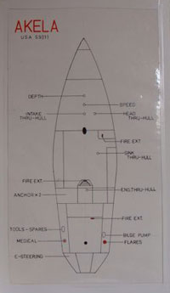
Akela’s storage diagram is a great reference and satisfies section 4.12 regulations

Safety Gear Location Charts
Safety gear and through-hull shut-offs are useless if they cannot be found in an emergency. That's the thinking behind Section 4.12, which requires a chart showing the locations on the boat where safety gear and be found. Adding through-hulls to this chart is an excellent idea. Your storage chart needs to be posted in a conspicuous position.

Emergency Steering
Depending on the nature of the race you’re entering and the instructions given to the inspector the requirements for emergency steering can be anything from a general discussion of using a spinnaker pole and floorboards off the stern, to having to demonstrate a replacement rudder and sail upwind and down. The Pacific races have had a long history of steering and rudder failures so it’s not without cause that Transpac and Pacific Cup inspectors look upon explanations of how racers will sail 1,500 miles downwind by moving drogues from side to side with a certain amount of incredulity.
The best rudder, of course, is generally the one your boat came with originally and not some contraption bolted to your transom. A thorough steering and rudder inspection prior to departure is the first line of defense against losing your rudder. It’s not just the rudder: commonly it’s the steering chain, or cables, or sheaves, or quadrant, or bolt holding the quadrant to the rudder shaft, or the bearings upon which the rudder turns. All of these are potential sources of failure and should be inspected before departure.
There are some production (and possibly custom) boats which are built so that the rudder shaft and quadrant are entirely inaccessible. The lazarette and cockpit seem to have been installed after the rudder and no boatyard worker, no matter how small, can prep the rudder to have it dropped out for inspection. Obviously, you don’t want to take such a boat to Hawaii or Bermuda since you can’t inspect it ahead of time. Jim Antrim, a bay area local and respected naval architect, has some excellent information on his web site about rudder inspection and emergency rudder considerations.
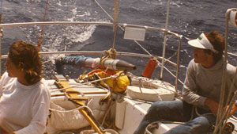
John Jourdane and crew sailed Brooke Ann for hundreds of miles using this sweep.
What are some possible solutions to emergency steering?
- A separate rudder and tiller attached with pintles and gudgeons to the transom of the boat. If you build a second rudder, it’s recommended that it extend far enough into the water to be effective, not be too large, so the loads don’t overwhelm its strength and be able to be installed at sea. The shape should be fat and the rudder does not have to be smooth to be effective.
- An improvement to a rudder hung on pintles is a rudder which slides inside a “cassette”. The cassette is above the waterline and pivots on pintles and gudgeons. The rudder blade slides down inside the cassette, which makes it much easier to install at sea.
- Several boats have demonstrated their ability to be steered upwind and down with a spinnaker pole which is attached to a universal fitting at the lowest extremity of the transom. Using a line to pull the pole down into the water, plus lines which allow the pole to be swung from side to side, the pole/rudder has enough force to swing the stern from side to side. Warwick “Commodore” Tompkins developed this method in the late 90s.
- Spinnaker poles can also be used with floorboards or other flat materials to create a “sweep”. This is what sailors generally think they can do, but relatively few boats have made this work. John Jourdane has a picture of his crew sailing Brooke Ann in the Caribbean using this method.
- Finally, and it’s sort of unrealistic to say “finally” since I suspect there are a hundred other possibilities, several boats have been successfully sailed using a drogue off the stern which can be pulled to one side of the transom or the other. By moving the attachment point of the drogue, the boat can be forced to point in the intended direction. This is generally a method of last resort and when your landfall is downwind.

Tools and Spare Parts
Section 4.16 requires tools and spare parts and you can buy some Damage Control (DC) kits from suppliers if you don’t know what to put into one. The Navy has created a DC kit for their Navy 44s which comes in a large plastic tackle box and contains items which are not exactly “yachty” including giant hose clamps, a 2lb. sledge, a pruning saw, tapered plugs, wooden wedges, underwater epoxy, drywall screws, and a variety of other items which solve many problems. You’re not making furniture; you’re likely tearing apart the interior so that you can stop the inflow of water, or shoring up some compromised section of the hull. Neatness doesn’t count nearly as much as getting to shore with all of your crew intact.
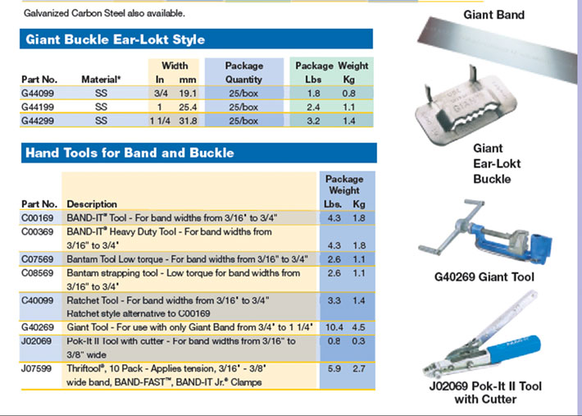
It is required that you put your vessel name on items that are likely to float away if your boat sinks so that rescuers know the equipment and vessel are yours.
Section 4.18 requires that floating items that begin with the letters L-I-F-E need to have retro-reflective tape on them. Life rafts, life buoys, lifeslings, and other safety gear will be dramatically easier to see at night when it has SOLAS tape on it. Note that this only works for the person with the searchlight; it’s retro-reflective after all, which means that it reflects back in the direction the light is coming from. Those with the light get an immediate brilliant return, while everyone else wonders what all the excitement is about.
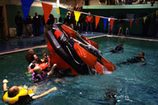
Capsize practice at Vallejo, CA Safety at Sea Seminar
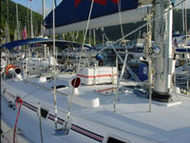
Charter boat in Tortola. While the raft is sort of in the way, it is much easier to launch it when it is above decks.

EPIRBs and Life Rafts
4.19 requires that you have an EPIRB. Few marine safety items have made as great an impact as emergency position indicating radio beacons to sailors who sail in Category 1 races. Buy one with a built-in GPS receiver, register it, and make sure everyone on board knows where it's stored and how to operate it.
The topic of life rafts is complicated due to the overlapping and similar sounding regulations that rafts meet. ISO (International Standards Organization) and World Sailing came up with very similar life raft standards about ten years ago and eventually acknowledged each other's standards. Older style rafts built to the ORC (Offshore Racing Council) standard are grandfathered in if they were built prior to 2006. You’ll notice that this section of the Special Regulations has more clauses than all the Macy’s stores in December, due to the obvious challenge of upgrading a standard without making rafts that are currently in use on racing boats obsolete. If you have an older raft, make sure it meets older ORC requirements, which are detailed in Appendix A, Part 1. If you’re buying or renting a life raft, make sure it complies with Appendix A, Part 2.
Everyone seems to agree that insulated floors on rafts are a good idea, and yet most of the longest examples of survival have happened on rafts with uninsulated floors. To convince yourself of the desirability of an insulated floor, sit in a raft in relatively balmy conditions without one (say, in Newport Harbor with 60-degree water). In less than an hour, you’ll wish that you had something between you and the ocean to keep your heat loss to a minimum. The colder the water, the sooner this will occur to you.
It used to be permissible to store smaller life rafts below decks, but now all rafts have to be either mounted on deck in a cradle or stored in a locker designed for life raft storage. This makes a lot of sense, as rafts stored below have two failure modes: they can either be inflated below which can tear a boat’s deck off, or they cannot be brought to the working deck prior to the boat sinking. Either is to be avoided. Store rafts where they have a chance of doing their jobs.

Life Raft Inspections and Repacking
Section 4.20.5 deals with the frequency of inspecting and repacking life rafts. Generally, the manufacturer of the raft is the best judge of this, but World Sailing has arrived at the conclusion that World Sailing-spec rafts should be inspected no less often than every three years, then two years, then one year thereafter. There are good reasons for life raft inspections: some items deteriorate, rafts tend to abrade on the hard folds inside their containers, and water can seep in and wreak havoc with sensitive inflators and high-pressure cylinders. It’s odd that World Sailing prescribes the inspection interval; one can imagine that a World Sailing member had a bad experience and is trying to keep other sailors from experiencing the same fate.
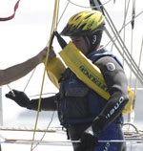
The Lifesling really works. See the Safety Section of our West Advisor Landing Page for a writeup on the 2005 Crew Overboard Symposium on San Francisco Bay by John Rousmaniere.
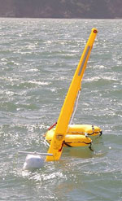
When you deploy a “MOM”, what are you actually providing to the victim? Here's one in use on San Francisco Bay.

Man Overboard Gear
Lifebuoys (Man Overboard Gear) are required, and due to the popularity of the Lifesling in the U.S., the US Sailing prescription requires that one of the two required devices be a Lifesling. It must have a self-igniting light, and there are a variety of water-activated lights that can be attached to the straps of the sling. Earlier versions of the Lifesling had a purpose-built pocket at the back of the sling, but tests indicated that it would be more effective mounted on the straps. In addition to the light, you should also attach squares of retro-reflective tape to the tops and bottoms of the Lifesling so it is visible at night.
The second “lifebuoy” is generally a MOM 8, or Man Overboard Module. This device was invented about 30 years ago to solve the issue of having a pole, drogue, life ring, and light in a small package. By making most of these components inflatable, the MOM 8 allows a lot of gear to be deployed in a short period of time by pulling a single pin. The MOM will provide a point of reference for the boat as she returns to find the victim and the MOM can be deployed so quickly that it practically hits the victim on the head as he passes by the hull. The MOM 8 requires biennial servicing, generally by the same company that serviced your life raft.

Flares, Smoke Signals and Flashlights
Section 4.23 concerns pyrotechnic and light signals, commonly known as visual distress signals or flares. Racing sailboats are required to have SOLAS-grade signals, which are dramatically more waterproof and brighter than conventional recreational signals. This is an example of where adhering to a commercial standard (SOLAS governs what ships have to carry) adds dramatically to the effectiveness of the device. You must have six red parachute flares, four red hand flares, and two smoke signals. The flares must also be within their expiration date, which is 42 months from the date of manufacture.
SOLAS signals are one of the expenses of going on ocean races. On the other hand, they are extremely good signals and if you’re in trouble, at night they make your boat stand out against the dark sea and sky. One piece of advice would be for Transpac sailors to consider selling their SOLAS signals to Pacific Cup sailors at the end of the signals’ useful life, since the races are on opposite years. That way, it might be possible to get four races out of each purchased set of signals, e.g. races in the summer of 2012, 2013, 2014, and 2015. It might take more cooperation than is justified, but it's possible to get four races out of a product with a 3.5-year useful life.
4.23.2 also requires a flashlight (with spare bulb and batteries) and a white spotlight for collision avoidance. These two devices are not well defined. We suggest having a compact LED flashlight for every sailor onboard and consider having a supply of quality headlamps (again, LEDs work well) for at least half the crew and preferably all of them.

Throw Rope
The heaving line requirement is best met by a heaving line in a bag, sometimes called a (Rescue) throw rope. This should have a permanent place at the helm or pushpit and should be 70' long. This one doesn’t have to be particularly strong (perhaps 1,000lb. is sufficient), since you can use it to pull a larger line to a vessel that is going to be towed or going to do the towing. Heaving lines are a great way to get a line to a person in the water without maneuvering the vessel too close by. (4.22.7)
The knife that’s required in 4.25 can be a diver’s knife with a blunt tip, a sharp serrated blade on one side, and a straight blade on the other. The sheath can be strapped to the pedestal, and a second knife can be strapped to the mast (and a third knife can be strapped to the pulpit).

Storm Sails
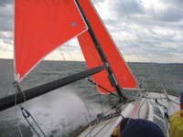
Trysails should not sheet to the end of the boom.
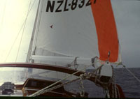
You can’t be sure that your boom will still be in one piece, so it cannot be counted on to help in trimming the trysail. Photo credit: John Jourdane.
You are better off going to your sailmaker and asking him or her to make you a set of storm sails rather than trying to figure it out on your own. Storm sails are tiny, flat, and extremely strong. In survival conditions, very few sailors argue that their sails were too small.
Some pointers:
- Trysails are commonly at odds with batten car systems on modern mainsails because the external track does not allow the trysail to share the track with the main. In that case, a secondary track, parallel and offset to one side of the main track, is virtually the only answer. Some new masts have actually come with gates that allow the two sails to share a common track, but it's generally built into the boat at the factory.
- Trysails should not sheet to the end of the boom, or require that a boom be present. A trysail sheets like a jib, with two jib sheets and no interaction with the boom. One of the common reasons to use a trysail is because your boom is in pieces after a round-down.
- Furling headsails create a challenge for bending on a storm jib. You either have to unroll your furling jib entirely and tack it off the furler (which can be difficult to do on a windless day at your slip), or you have to use a different stay, or you have to use a sail that goes over your furling jib. ATN makes a storm jib called the Gale Sail which attempts to solve this issue by allowing the luff of the storm jib to be zipped around the furled jib while it’s in place.

Drogue or Sea Anchor
Section 4.27 requires that the vessel have a drogue or a sea anchor. A sea anchor is a very large drag device shaped like a parachute, which is deployed off the bow and designed to reduce the sternway of a boat to less than a knot. It must be used with a long nylon line, which can be the anchor rode, to absorb the shock of waves hitting the boat. A drogue is deployed off the stern, is far smaller (perhaps 5' in diameter), and is used to keep a boat from accelerating to surfing speeds on the face of a wave. Properly-sized drogues roughly halve the speed of the boat. Para-Tech and Fiorentino are two popular brands of drag devices.

Section 5—Personal Equipment

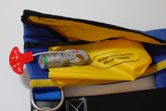
Inflateable life jackets satisfy requirements and lay flat until they are needed in an emergency
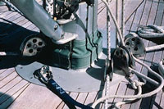
Locking carabiner on a padeye at the base of the mast. The centerline connection point makes it impossible to go over the side of the boat. Very secure.
Section 5 deals with the gear that each crewmember wears on his or her body. Due to the differences in the standards organizations in the U.S. and the rest of the world, the life jacket section gets complicated quickly. If you skip down to the large US Sailing prescription in bold italics, it says that in the U.S. you need to either have a Coast Guard Type I device (which makes virtually no sense on a recreational boat, whether racing or not) or an inflatable flotation device that meets either a British or European Community standard. This is curious since inflatable flotation devices have been approved in the U.S. for over a decade, so it’s not obvious why the prescription would look east for compliance.

Life Jackets
So what kind of flotation device are they describing? It's a single chamber inflatable life jacket with 150 Newtons (33.7lb.) of buoyancy with a gas inflation system. In the US, such devices are generally called “Offshore” life jackets, but the Coast Guard and UL attempt to place them in the various “types” of life jackets that are also used for inherently buoyant products. This is where things get tricky, and it’s probably a good idea that US Sailing and World Sailing steered well clear of the confusing Type designations that are in use in the US.

Safety Harnesses
In the very next section, 5.02, you'll find the requirements for safety harnesses and safety lines. What becomes immediately clear for most sailors is that the way to both meet the requirements for the life jacket and safety harness sections is to buy a single product that combines both products. Thus, an offshore sailing life jacket with 35lb. of buoyancy (some have slight more or less, but we generally call them 35lb. life jackets) and a means of attaching a safety tether (D-rings) is the ultimate answer. Some offshore crews will elect to go with a separate harness and life jacket, but generally the two are combined.
Safety harness lines (tethers) have come under greater scrutiny and now have multiple requirements on how they are constructed. In general, they cannot be old, they cannot use magnetic hardware and they can’t be longer than 2m. We have always recommended tethers which can be released at the chest end with a single pull of a release cord since boats can sink quickly and you need to release yourself from the vessel. You’ll also need to have 30 percent of your tethers in a double configuration so that you can shorten the length to 1m.
Finally, 5.09 requires that you practice the QuickStop man-overboard maneuver on an annual basis. You will be required to show an affidavit that says that you and your crew have done such a practice (and it’s a damned good idea to practice until perfect).

Section 6—Training

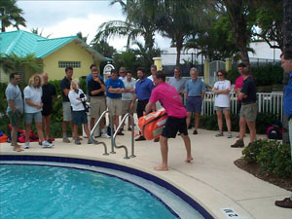
Safety at Sea Seminar in Miami for the stopover of the Volvo Ocean Race in 2005. While there was a wide range of experience among the attendees, all reported that they gained something from the seminar.
30 percent of your crew, including the skipper, must attend a Safety at Sea Seminar every five years. Generally, there will be a seminar scheduled in the vicinity of the race starting location in the spring before the start. For West Coast races, seminars have been held in Seattle, Portland, Vallejo, Oakland, San Francisco, Santa Cruz, Long Beach, Newport Beach, and San Diego. However, every year there are crews who discover late in the process that they need to attend a seminar, but the only seminars that are available are 2,500 miles away. Plan ahead!
There are two categories of Safety at Sea Seminars in the US. One is a single eight-hour day of lectures and demonstrations, generally held in a yacht club or community building. This meets the requirements for virtually all US Category 1 races. The second is a two-day event which combines lectures and demonstrations on one day, and hands-on activities including in a pool with life jackets and life rafts on the second day. The two-day course is designed to meet World Sailing requirements which are described in 6.01. The advantage of attending a course that meets World Sailing requirements, other than the additional skills and education that you’ll receive, is that your training certificate is recognized worldwide.
Finally, you should have two crewmembers on board who hold Senior First Aid Certificates, including the specific issues which occur at sea like hypothermia and seasickness. In the U.S., many of the first aid and first responder courses are intended for land-based accidents and have little relevance for mariners. Courses are offered in many communities specifically designed for either commercial or recreational sailors which will prove to be more applicable for our sport.

Special Regulation Appendices
The appendices of the Special Regulations contain clarifying material (life raft specifications, how to conduct a Safety at Sea Seminar), as well as practical information about medical conditions, man overboard, drag devices, and a full index of the regulations. Of special interest to the owner facing a yacht inspection is Appendix F, the Standard Inspection Card. Not every race or boat inspector will use Appendix F, although some Notices of Race may specify it. The “card” doesn't go over every section of the Special Regs, and it would be risky to presume that the inspector will limit his/her inspection to just what’s on the card.
Having inspected perhaps fifty yachts prior to Category 1 races, the author has a few recommendations for those facing inspection to ensure that your boat won’t either require re-inspection or have a list of comments which need to be rectified prior to the start of the race.
- Mast butt attachment?
- Bilge pumps have handles with lanyards?
- Flares within expiration dates?
- Companionway hatch slide able to be operated and locked from above and below?
- Emergency steering has a chance of working in storm conditions?
- Anchor and rode realistically sized for the yacht?
- VHF radio has adequate coax and a real antenna?
- EPIRB is registered to the yacht?
- Jacklines are made out of correct materials?
- Life jackets have enough buoyancy?
Good luck, sail safely and arrive in good shape.

